**1. What QA methodology would you establish?**

Since there is already a previously formed team in the project including manual testers and they have already adopted a working methodology, be it SCRUM, Cascade, etc. In conjunction with the functional tester, we would proceed to analyze the documentation and the test cases that were previously carried out to define which is the critical path focused on the business (given the requirement of regression tests), verify if there are unit tests and finally review execution times.

As well as documenting and assigning bug reports in a Kaban log for follow-up and control.

**2. What testing types would you have your team perform?**

Initially, I would talk to the developers, instructing them to unit test the code to begin to ensure the quality of the software and establish a percentage of coverage.

As an automatizer, I select key test cases that provide a greater degree of reliability of the test, the development of automation would be focused on behavioral tests on flows that a user performs. Such automated cases would be run for regression testing.

**3. What tools/software would you recommend using for testing?**

Since the platform has a user interface, I would use Selenium as one of the best known and most supported tools for automated testing.

It would be used as a Java programming language with Gradle as a compilation tool, in which I would import the *Selenium* and *ScreenPlay* library, which allows me from the beginning to structure and apply good development practices such as SOLID to the automation project.  
As I would also use libraries such as Bonigarcia's *WebDriverManager*, which allows me to use the browser driver without having to download ChromeDriver for example.

If a test case requires consuming a service either as a precondition, we can use the *RestAssured* library.

If a test case requires connecting to a SQL database to validate the information, we can use the *mysql-connector-java* library

**6. How would you address automation in this project taking into account the complexity of the platform and that there are 5 years worth of functionality that has not been automated?**

When I have read the documentation and have understood the application; I would proceed to speak with the manual testing team to review the test cases, determine the critical path and define which are the most repeated test cases.

Also check what tools the project has to evaluate automation capabilities, for example: test environments, test data, application deployment, permissions and extra accessibilities.

**7. How would you transition the current QA team from performing functional testing to automation without sacrificing quality and speed?**

There are test cases that cannot be automated or that are more expensive, for example validating the design of a button. Therefore, the manual test team can be trained so that they themselves can download the automation project, run the test cases they require and finally verifying the results, leaving only some tests manually, this would imply time optimization, such as It would also help the current QA team to give you the ability to automate.

**8. How would you implement a Continuous Delivery flow in production ?**

Considering that automated regression testing will be done by QA, it is necessary to have a stable, production-like test environment to run the tests and verify the results. Our CD would have the following phases:

**Version Control:** A version control repository is implemented for the changes that are made in the application.

**Build:** The libraries and complements required to compile the code are downloaded to later be packaged.

**Unit test:** The unit tests that were established in the code are carried out.

**Artifactory Version Control:** A version control repository of the artifacts generated in the previous phase is implemented. example: .jar

*From here each phase is executed through manual intervention, since we are using Continuous Delivery.*

**Deploy env:** It is defined in which environments the application or generated artifact would be deployed. In our case we would need a QA environment.

**Test:** The different tests are carried out in the QA environment, in this case it would be the regression tests to validate that the change has not affected the functionality.

**Deploy Prod:** The application is deployed in the production environment.

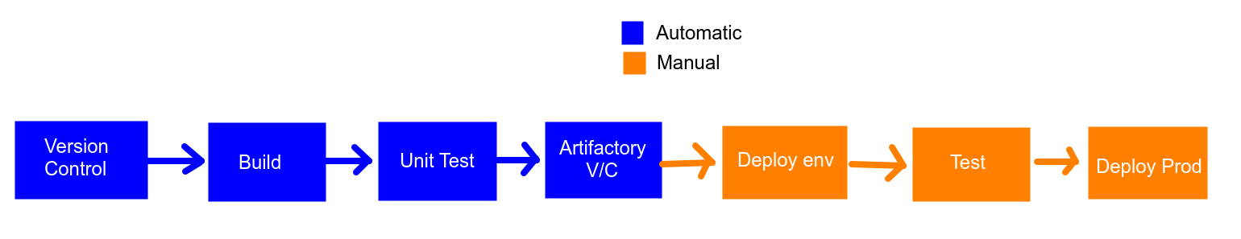

**9. Which processes, techniques and tools would you use to do QA automation for cross browser and cross device testing the most effective way possible?**

The most viable option for Cross Browser testing would be *Zalenium*; because it allows us to configure and test in different browsers, with different resources and even parallel tests.

In the project we would implement the design pattern ‘*Dependency Injection*’ and avoid using ‘*public static*’ in critical variables, to avoid causing errors in tests with parallel execution; When we instantiate the browser we use a variable ‘*ThreadLocal <RemoteWebDriver>’* for the use of threads for each node and through an Interface we can configure the capabilities.

There are different platforms in the cloud that allow us to carry out tests in different browsers and devices, even versions of these; however they tend to be expensive depending on the use, for example we have *Lambdatest* which is very popular and has many extra features like *CrossBrowserTesting*.